2026 ‘Korea Day’ Festival
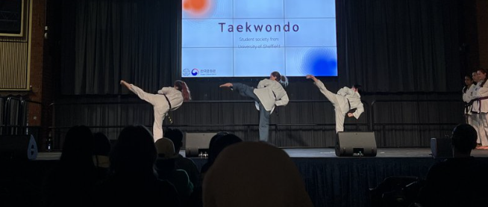
This year, the Korean Cultural Centre UK (KCCUK) aims to bring the vibrant energy of Korean culture to cities across the UK with a series of exciting ‘Korea Day’ festivals. Partnering with local universities and organisations, these events have been a highlight of the KCCUK's cultural calendar since 2018. Each ‘Korea Day’ offers a chance for students and citizens to experience the dynamic blend of tradition and contemporary Korean culture.

For those who are interested, please check the attached file for the application pack for the 2026 ‘Korea Day’ Festival.

□ Applications
ㅇ Application open to authorities of organisations, Professors and Lecturers in the University, Korea-related Communities in the University
ㅇ Deadline: 27th February 2026
ㅇ Submit via email: ys.jung@kccuk.org.uk

□ Conditions
ㅇ Event Report to be submitted within a month after the event
ㅇ Budget should be spent only for the Korea Day event, proof of budget use will be required.
ㅇ Submission of pictures and videos of the event
ㅇ Submission of satisfaction survey (form will be shared)

2026 Korea Day Festival
- Application Pack -

Uni/Region
Department
Event name | ex: Korea Day in OOO
Date of submission | 20 . MM. DD.



□ Aims
ㅇ
ㅇ

□ Event Overview
ㅇ Event name:
ㅇ Date:
ㅇ Place:
ㅇ Organiser: Korean Cultural Centre UK
ㅇ Co-operating organisation:
ㅇ Budget:

□ Direction of Propulsion
ㅇ
-
-

□ Event Outline

ㅇ Explanation of the event
- (major events) Hanbok experience, Korean Calligraphy etc.
- ( )
- ( )

□ Event Time Table
Date | Time | Place | Programme | Programme summary

□ Budget Plan

Total Budget:
Korean Cultural Centre Budget: | Additional Budget:

■ Specific Budget Plan
Total Budget |  | £
Budget breakdown
Date | Product | Information of product | calculation | Price
 | Space hire |  | Estimated price x days
Total
■ Additional Support
※ If there are additional support from other organisations, please share the information in the cell below.

Additional financial support |  | £
Budget Breakdown
Date | Product | Information of product | Price | Organisation
Total

